OOP Project

# Related image**Project Analysis Report: Iteration 2**

CS 319 Object Oriented Software Engineering  
Eray TÜZÜN  
Group 1-I: Private Moon Inc.

Project Group Members

* Doğa Oruç – 21602022
* Fazilet Simge Er - 21602358
* Kaan Ünlü - 21602622
* Ege Turan – 21502441
* Çağrı Orhan - 21503102

Project Analysis Report: Iteration 1 0

1 INTRODUCTION 2

2.0 PROPOSED SYSTEM 2

2.1 Overview 2

2.2 Game Algorithm 3

2.3 Server 3

2.4 Game Objects 3

2.4.1 Provinces 4

2.4.2 Continents 4

2.4.3 Dices 4

2.4.4 Card 4

2.4.5 GameBoard 4

2.5 Gameplay 4

3.0 FUNCTIONAL REQUIREMENTS 4

4 NONFUNCTIONAL REQUIREMENTS 5

5.0 SYSTEM MODELS 6

5.1 UML Diagrams 6

5.1.1 Use Case Diagram 6

5.2.2 State Diagram 9

5.2.3 Sequence Diagram 9

5.2.4 Class Diagram 10

5.2.5 Activity Diagram 10

5.2 User Interface 10

5.3 Screen Mock-ups 10

5.3.1 Main Menu 10

5.3.2 Play Online 10

5.3.3 Play Offline 11

5.3.4 Game Screen 11

5.3.5 Settings 12

5.3.6 Rules 12

6.0 REFERENCES 12

# 1 INTRODUCTION

Private Moon Inc.’s Project Risk is a digital revival of the 1957 table-top classic Risk [1]. The original game is a 2 to 6 player game that rewards strategizing and a silver tongue.

The game consists of a game board, 6 sided dice, cards and pawns. The game board is usually a map of the world with named provinces. The provinces are grouped inside continents of different colours. There are two types of dice: Red and White. Also, there are 2 different card types: Province Cards and Secret Mission Cards. Finally, there are 6 different colours of pawns meant to be used by up to 6 players. These pawns can be found in three different shapes, usually dubbed infantry, cavalry and artillery, symbolising 1, 5 and 10 armies respectively.

The objective of the game for a player is either to conquer the entire world or if the players decide to play with secret missions, finish four secret mission before the others do. For this, each player takes a turn one after another and act to conquer new lands. Each player turn has three phases:

* As their turn begins, the player gets a number of new armies equal to their total number of provinces divided by 3 rounded down, plus the value of their continent if they completely have conquered one, plus the next number on the army table to the bottom of the game board if they have turned in 3 province cards of the same marking, or 3 province cards each of a different marking. Also if any of the cards the player has turned in that turn has a province they already have pictured on it, they receive an extra 2 armies specifically for that province. The rest of the armies can be deployed wherever the player wants.
* Then, if wished so, the player can attack a province neighbour to one of their own provinces where the attacking province must have at least 2 armies in it. The player can attack as many times as they want on the same or on different provinces. On any singular attack, the attacking side can choose to roll up to 3 red dice (where DiceNumber < armiesOnAttackingProvinceNumber) and in response the defending side can choose to roll up to 2 white dice (where DiceNumber <= armiesOnDefendingProvinceNumber). All dice are rolled, and the maximum white dice number of attacker’s dice rolls are compared against the results of the white dice. The red dice have to score higher than white dice, or for every die that doesn’t, an army on the attacking side perishes. The opposite of this happens for every higher red dice value: An army on the defending side perishes.
* Finally, to fortify their position, the player can move as many armies as they want from one and only one province to one and only one other neighbouring province [2]. The fortification can only happen between connected provinces.

This digital cut of Risk will be colour-blind friendly, include online and offline multiplayer, have multiple language support and mod support allowing people to create their own maps and integrate them into the game in addition to the features of the original game.

# 2.0 PROPOSED SYSTEM

## 2.1 Overview

The following features will be added to the game according to the MoSCoW principle:

The Game must have:

* A Map
  + Whose provinces can be selected viewed accurately
  + On whose provinces armies can be deployed, viewed and sent to other provinces in transportation or attack
* Logic and visualization to show the number of armies received at the start of a turn
* Turn logic which includes the 3 traditional Risk turn phases
* Initial troop deployment logic
* Game victory and failure logic
* Dice and card shuffling logic
* Province and secret objective cards
* Offline playing capability with friends
* Online playing capability over direct IP
* Offline playing capability over AI
* Limited multiple language support
* Limited colour blindness support

Should have:

* Mod Support
  + Filter based colour blindness support
  + Multiple resolution support
  + Custom map addition support
* More languages
* Better dice and card visualization

Could have:

* Music and sounds
* Map zoom
* Better province name visualization
* Server based online multiplayer capability
* Extra visual themes
* AI, with flavour
* Game saving in offline games
* Diplomacy mechanics

Won’t have:

* Micro-transactions, loot boxes
* Accounts
* Game saving in online games

## 2.2 Game Algorithm

The game is based on turns. At the end of each turn if a player has no provinces left, they lose. Else if they have all the provinces under their control or if they have completed the secret objective on their secret mission card, they win.

## 2.3 Server

In the online multiplayer version of the game, data transfer between the host and the clients are needed. We do this by creating a “Socket Server” and uniting the users on that server for data transfer. This feature also allows us to create a chat on the server. When a user starts a new multiplayer game, user has to create a room which means SocketServer object is created to bind people. After constructing a SocketServer, players will connect the server as a Client. A user may decide how many players going to be in a game room so that server can deny the extra requests. After each turn, needed game objects is send to each client in order to update the game process. In order to provide synchronized data on each client, we are using multi-thread class.

## 2.4 Game Objects

Game objects are the visual components on game screen and users can interact with those objects.

### 2.4.1 Provinces

Provinces objects are territories on the Risk map. There exist forty-two provinces on the game map. Also provinces have ownerships that are seen on screen with user’s colours. Every province has a unique name. Only ownerships of provinces may change by capturing.

### 2.4.2 Continents

Province clusters generate Continents object with the total of six Continents with unique names. Players try to conquest an entire Continent in order to take bonuses.

### 2.4.3 Dice

Dice objects are traditional dice with the number on each side. When a player rolls a dice, random generator gives a number (1-6) and prints on the screen. The result of battles between users is determined by rolling dices.

### 2.4.4 Card

A card object is given to a player when a player captured a province. Card objects are exchanged with soldiers. A player only can see the other player’s cards numbers.

### 2.4.5 GameBoard

GameBoard object is the main connection with user. GameBoard object has all the objects that a user may want to interact.

## 2.5 Gameplay

After entering game, user is going to encounter with a screen with multiple choices. Choices are as follows

When a user enters the play button, panel offers 2 option

* Single Player: In single player mode user will play against computer or friends turn by turn on the same computer.
* Multiplayer: Server will be created and other player will be waited for connect the server.

Next step is deciding which provinces to have turn by turn. After selecting provinces, users deploy armies on their provinces. Now game is ready to be played.

# 3.0 FUNCTIONAL REQUIREMENTS

Following properties will be provided in our Risk game:

* Play Offline Mode
* Offline Multiplayer will be available.
* AI’s can be added to the game to play against computer.
* Play Online Mode
* Online Multiplayer mode with a chat panel will be available.
* Settings
  + Audio Settings: Users can adjust the music and effects sound, or master volume of the game.
  + Language Settings: There will be multiple language choices available to play the game.
* Rules
* This screen will provide information to the user about fundamental rules of the Risk Game and common hints for success in game.
* Rules will be accessible from both the main menu and the in-game settings menu.

# 4 NON-FUNCTIONAL REQUIREMENTS

Non-functional requirements increase the significant of the game. Ways of well coding can be done by adapting important concepts. Non-functional requirements may help to meet the customer’s expectations more.

* **Usability**

Even a new player of the Risk game should be able to play the game without any obstacles. Menu items are to be limited to items less than 9 and players should be able to access the game rules from both the game and the main screen.

* **Performance**

In order to get through to a wide audience, game must run at optimal performance. Optimizations will be done to keep the game over 60FPS in any computer that can run Java with their GPU.

* **Reliability**

The game will be tested by other fellow students at various intervals to detect bugs without impeding our development tempo.

The game will also include a rollback mechanism that will allow the game to restore to the last saved working state after a crash. A log will also be created for the crash for us developers to look into.

# 5.0 SYSTEM MODELS

## 5.1 UML Diagrams

### 5.1.1 Use Case Diagram

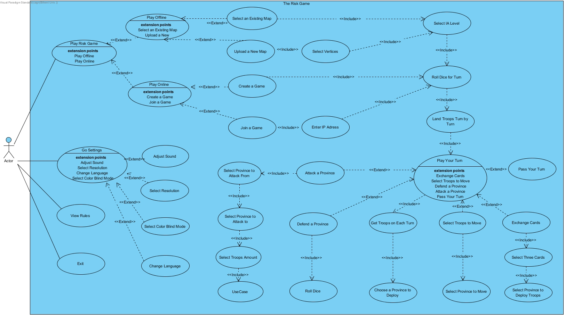

##### Use Case #1

Unique Name:

* Roll Dice for Turn

Participating Actor:

* Player

Entry Conditions:

* All Players have to be ready
* Users have to be connected to the Internet

Exit Conditions:

* Player must press Quit button from Menu in the game
* If there is no Internet connection

Flow of events:

* Player has to press play online button
* Player has to enter a server and enter a valid IP address

##### Use Case #2

Unique Name:

* Attack a Province

Participating Actor:

* Player

Entry Conditions:

* Players has to wait for their turn
* There has to be a valid province and more than one troops on that province
* Player has to press attack button.

Exit Conditions:

* Player must press Quit button from Menu in the game
* If there is no Internet connection

Flow of events:

* Player has to press play online button
* Player has to roll dice for turn
* Player has to press attack button

### 5.1.2 State Diagram

#### 5.1.2.1 Turn of a Player

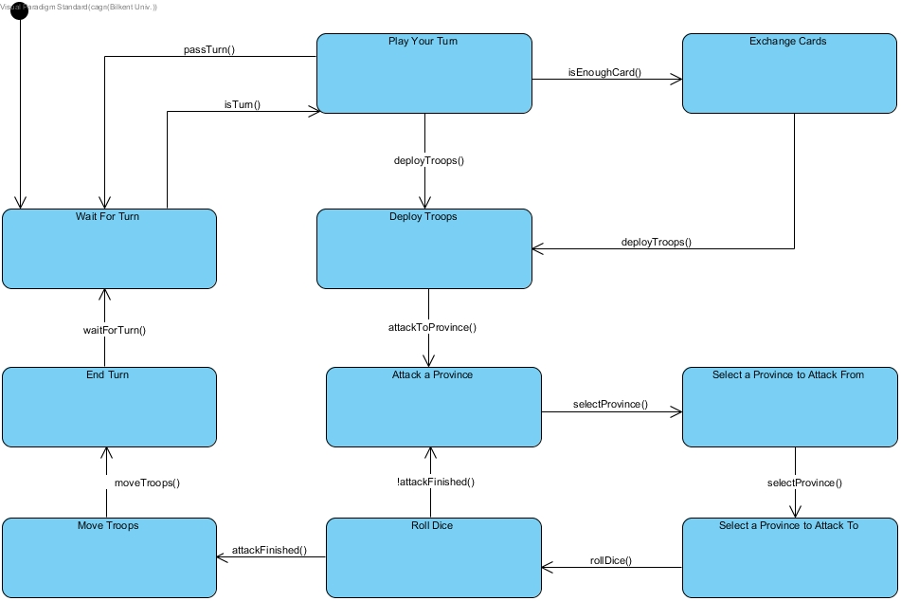

The state diagram above explains how a turn of a player processes. When a player's turn comes, the player can choose to exchange their cards if they have enough cards to exchange (if the number of cards they have is equal to five, the exchange is mandatory). Then, in the first phase of their turn, they will deploy new troops to the provinces they own. In the second phase, they can choose to attack as many neighbouring provinces as many times as they want, or just skip the phase. Lastly, in the third phase, they can move some troops from one of their provinces to another one, or just choose to skip it as well. With the third phase completed, the turn of the current player will end.

#### 5.1.2.2 Online Game States

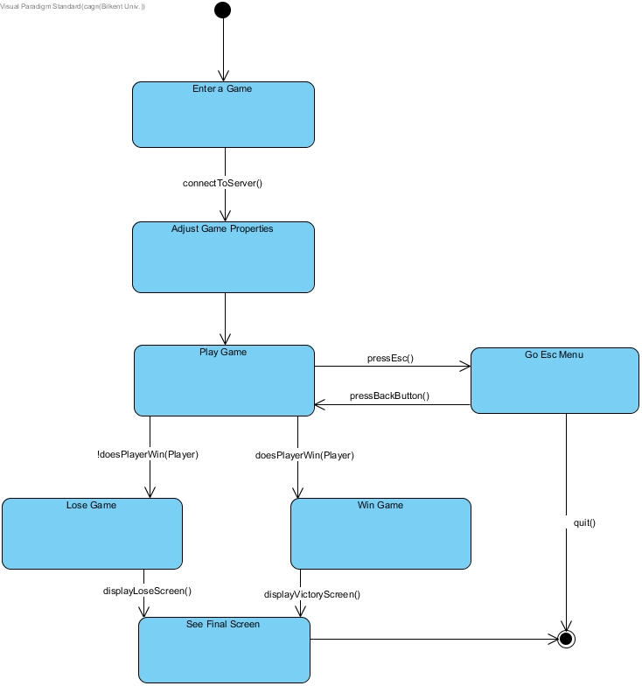

The state diagram above shows the flow of an online game. The player enters a game and connects to the server. After connecting, he/she adjusts the game properties. Then, the game starts. The player either wins or loses the game. This results in a final screen which shows the results of the game. Then, the game closes.

While playing the game, in-game settings menu can be opened. The player can quit the game from this menu as well.

### 5.1.3 Class Diagram



The entire class diagram is in high resolution and can be zoomed into greatly.

#### 5.1.3.1 Game Logic Module

##### 5.1.3.1.2 Classes in Game Logic Module

**Game Manager extends DoaObject:** This class controls the whole game system. It enables other classes to talk with each other and connects necessary components to maintain the game. For example, when a player tries to select a province to attack, the game manager will check if it is the player’s turn and if the province belongs to them and if the province has more than 1 troops. If game manager finds the players move suitable, the province will be marked as attacking province.

**Continent:** This model class represents a set of provinces. Objects of this class have a name, colour, capture bonus, abbreviation, and a list of province.

**Province:** This model class represent a province in the game. Objects of this class have a continent, as in which continent this province is in, a name, neighbours list and a list of meshes, centre of the biggest mesh, the owner player, a list of cards, and the number of troops. Meshes are used to detect mouse clicks on provinces. The centre of biggest mesh is used to draw the amount of troops inside this province.

**Player extends DoaObject:** This class is a model and a controller, represents an actual player. Objects of this class have a colour, and name.

**AIPlayer**: This class extends player class and represents a computer player.

**Card**: This class’ instances are used by the player class. All Players have a list of cards. Players can turn in 3 cards at the start of their turn to receive reinforcements. The turn in validity is again, checked by the game manager.

**Dice**: This class’ objects represent a set of dice. A dice object can represent a single die, a pair of dice and triplet of dice. When a player attacks a province, player sends a message to the game manager, game manager then creates 2 dice objects. Dice objects are created with respect to how many troops the player selected to attack. Informally, if a player wants to attack with 3 troops, and the defender has more than 1 troops in their province, the game manager object will create two dice objects, one will have a pair of dice(defender), the other will have a triplet of dice(attacker). We first planned to use a factory method to create Dice objects, but going with that approach wouldn’t have made our code structure better. On the contrary, it would obfuscate our code since writing a factory method just for the sake of writing a factory method is not our goal.

##### 5.1.3.1.1 Packages in Game Logic Module

DoaEngine is the game engine that we have used to configure our game system, it is written by our member Doğa Oruç. It enables us to create DoaObjects that will be updated and rendered every 4 milliseconds. All interactions and logic regarding the application is done by the tick() methods of DoaObjects.

#### 5.1.3.2 Networking Module

##### 5.1.3.2.1 Classes in Networking Module

**SocketServer**: This class is used for the connecting the players who will play online. It works as a server and uses a simple yet effective library called WaifuPnP to automatically open a TCP port at port number 27015 during runtime. Only the host of the game will have a SocketServer object, other players will have a Client object to connect to host player’s server. SocketServer sends Messages to Clients and receives Messages from Clients.

**Client**: This class is used to provide a connection with the host player’s server. It takes the hosts IP address and pings the server in question. If such server exists, the server will accept the request.

**MessageType**: This class specifies the types of message that can be shared between Clients and SocketServer. For example, when a message with type GAME_MOVE is sent to the server, the server will broadcast the message to all Clients, therefore synchronize all players.

**Message**: This class’ objects are used to communicate with the SocketServer and Clients. Each Client, when necessary, will send a message to the SocketServer. The SocketServer than processes this message and broadcasts another message to all Clients.

**MessageBuilder**: This class is used to build message objects.

#### 5.1.3.3 RiskUI Module:

##### 5.1.3.3.1 Classes in RiskUI Module

**GameBoard extends DoaObject:** This class has a single object. The object of this class renders the background image of the game to the screen. I.E. a world map.

**GameScreenVisualElements extends DoaObject:** This class has a single object. The object of this class renders the miscellaneous visual elements to the game screen.

**InfoPanel extends DoaObject:** This class has a single object. The object of this class renders the panel that holds the information about clicked provinces, like which continent a province belongs to, which player a province belongs to, how many troops are in a province.

**MainMenu extends DoaPanel:** This class has a single object. The object of this class allow for navigation between other menus.

**MiddleSectionScroll extends DoaObject:** This class has a single object. The object of this class is responsible for rendering the cards of the player. This panel has a single button that can be pressed to show/hide the cards of the players. This feature allows us to utilize the area the game screen has more efficiently.

**PieceGauge extends DoaObject:** This class has a single object. The object of this class render a gauge that shows, how many reinforcements a player will get when a set of 3 cards are turned in.

**DebugPanel extends DoaObject:** This class has a single object. The object of this class renders various information that may help us debug our game to the top-left of the screen. Examples include, the position of the mouse.

**TextImageButton extends DoaImageButton:** The objects of this class act as an image button with arbitrary sizes and locations.

**ProvinceHitArea extends DoaObject:** The objects of this class are responsible for rendering the borders and insides of the provinces.

**PlayOfflineButtonAction extends DoaUIAction:** The object of this class is supplied to the play offline image button in MainMenu. Creates an offline game.

**PlayOnlineButtonAction extends DoaUIAction:** The object of this class is supplied to the play online image button in MainMenu. Creates an online game.

**SettingsButtonAction extends DoaUIAction:** The object of this class is supplied to the settings image button in MainMenu. Takes the player to the settings menu where the player can adjust the master, music and sfx volumes respectively, and change the game’s language.

**RulesButtonAction extends DoaUIAction:** The object of this class is supplied to the rules image button in MainMenu. Takes the player to a panel that explains the game’s rules.

**ExitButtonAction extends DoaUIAction:** The object of this class is supplied to the exit image button in MainMenu. Exits the program.

**CardsButtonAction extends DoaUIAction:** The object of this class is supplied to the cards image button in the game screen. Hides/shows the MiddleSectionScroll.

**NextPhaseButtonAction extends DoaUIAction:** The object of this class is supplied to the next phase image button in the game screen. Messages the GameManager to go to the next phase of turn. A turn is DRAFT => ATTACK => REINFORCEMENT.

**UInit:** This class have no object. This class is responsible for initializing all of the UI Components of our game.

##### 5.1.3.3.2 Packages in RiskUI Module

**DoaImageButton extends DoaButton:** This package used from the DoaEngine, it is an abstract image button, and we simply extended the abstract base class and added the required functionality.

**DoaPanel extends DoaObject:** This package used from the DoaEngine, a container for UI components.

**DoaUIAction**: This package is used from the DoaEngine, supplied to a button to specify the action a button will take when it is clicked.

#### 5.1.3.4 Exceptions Module:

##### 5.1.3.4.1 Classes in Exceptions Module

**RiskException**: This is general type for exceptions, exists because we didn’t want to throw a generalized exception like RuntimeException. All the other exceptions extend this exception.

**RiskSingletoInstantiationException extends RiskException:**  This exception is thrown when a singleton object is tried to be instantiated more than once.

**RiskStaticInstantiationException extends RiskException:** This exception is thrown when a static class is tried to be instantiated.

**DiceException extends RiskException**: This is a general type for Dice related exceptions.

**DiceAccessException extends DiceException**: Thrown when an invalid dice index is tried to be accessed. A Dice object have an integer array. This array has 1, 2 or 3 elements inside. These elements are the rolled dice face values. When index 7 is tried to be accessed this exception will get thrown.

**DiceInstantiationException extends DiceException**: Thrown when a Dice object that will have more than 3, less than 1 dice is tried to be instantiated. By definition, Dice in Risk must have at least 1 die, at most 3 dice.

#### 5.1.3.5 Loaders & Globals Module:

##### 5.1.3.5.1 Classes in Loaders & Globals Module

**MapLoader**: This class has no objects. This class reads continent and province data from .mpdata files. .mpdata files are map data files for Risk.

**Utils**: Various toolkit function. I.E. rangemap, coordinatemap etc.

**AssetLoader**: Image and sound loader.

**Globals**: Various global constants. This will be removed later and will get replaced by .rdata files.

#### 5.1.3.6 Other classes

**Main**: Entry point of the game.

**Camera**: At first, we decided to have a zoom functionality in our game, but then this idea got smaller and smaller. Since we do not have any certainty about the zoom feature we decided to let the class stay. Right now, there is zoom functionality, it might get removed later.

**Mesh2D extends List<Vertex2D>:** A collection of Vertex2D’s. This class’ objects are used to determine the click region of provinces. If a player’s mouse is clicked on a mesh, the province that owns the clicked mesh will get selected by that player.

**Vertex2D extends DoaVectorI**: A Vertex2D is a 2 dimensional point in DoaEngine’s coordinate system. Used to supply points to Mesh2D’s.

### 5.1.4 Activity Diagram

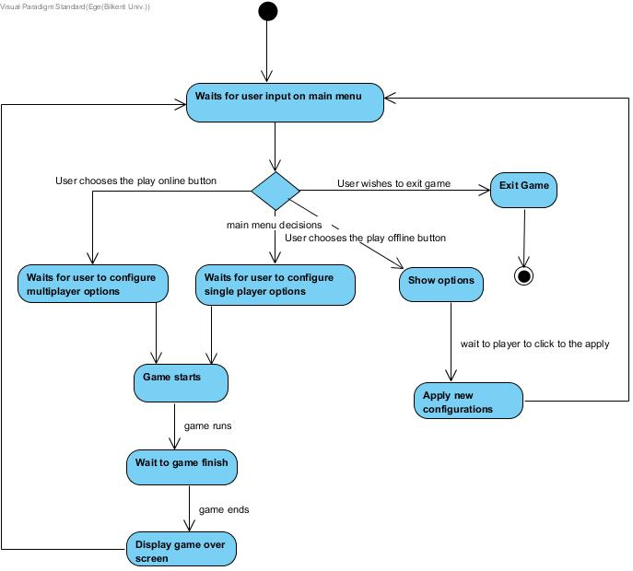

This diagram shows how our activities work. Firstly, we have main menu decisions and with the help of this main menu decisions option you can choose multiplayer game, single player game, options or you can quit the game. After game starts, it waits for game to finish. After that it shows the result and turns back to the main menu.

### 5.1.5 Sequence Diagrams

#### 5.1.5.1 Attacking a Province

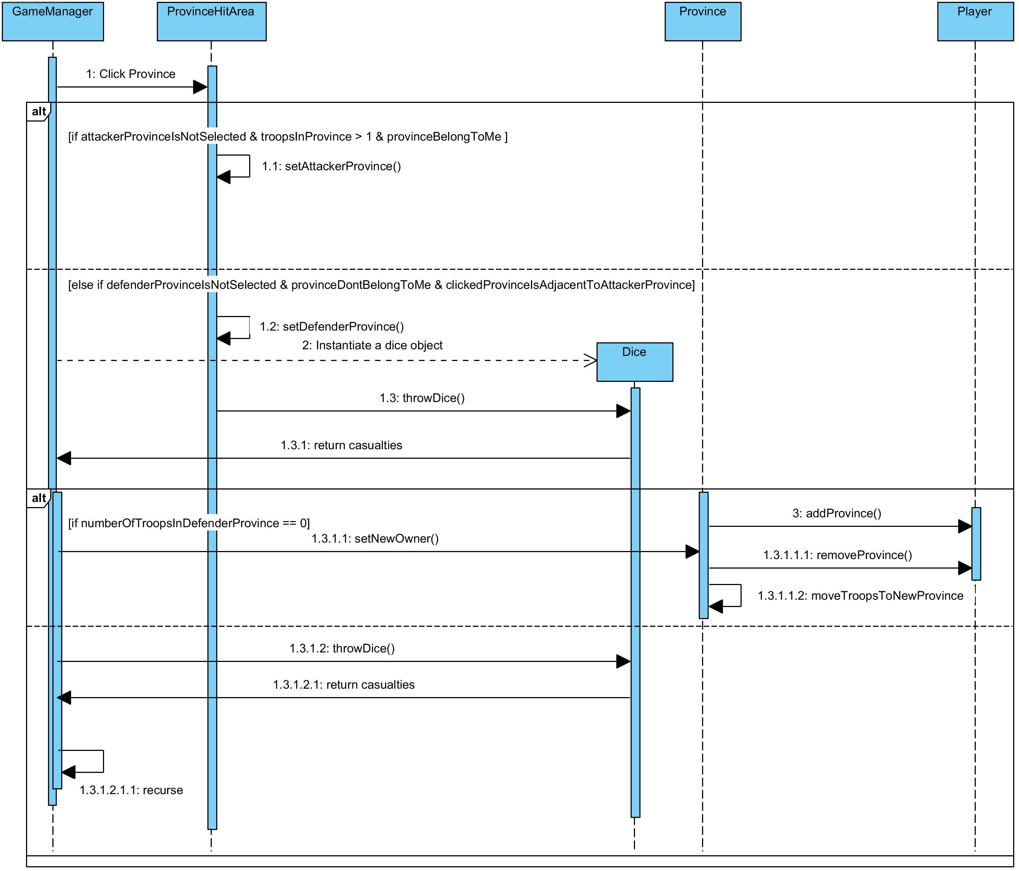

Attacking a province is the second phase of a player's turn. To attack a province, the player clicks one of the provinces they own at the beginning of their attack turn (the province must more than 1 troops on it). After that, they click one of the enemy provinces which are adjacent to the province chosen before. When both the attacker and defender provinces are chosen, 1-3 dice for the attacker and 1-2 dice for the defender will be rolled, considering the attacker player's choice of number of troops to attack with (for 1 or 2 attacker dice, the same number of defender dice will be rolled while for 3 attacker dice, only 2 defender dice will be rolled). The maximum values of the dice groups (attacker dice and defender dice) will be compared for each defender dice, and the player who rolled the dice with the smallest value will lose a troop on the respective province he/she owns. If the attacker player captures the province, they move at least the number of troops they attacked with to the captured province, from the attacker province.

The player who has the turn can repeat the process above as many times as they want, as long as the conditions above are satisfied.

#### 5.1.5.2 Manually Placing Troops in the Beginning of the Game

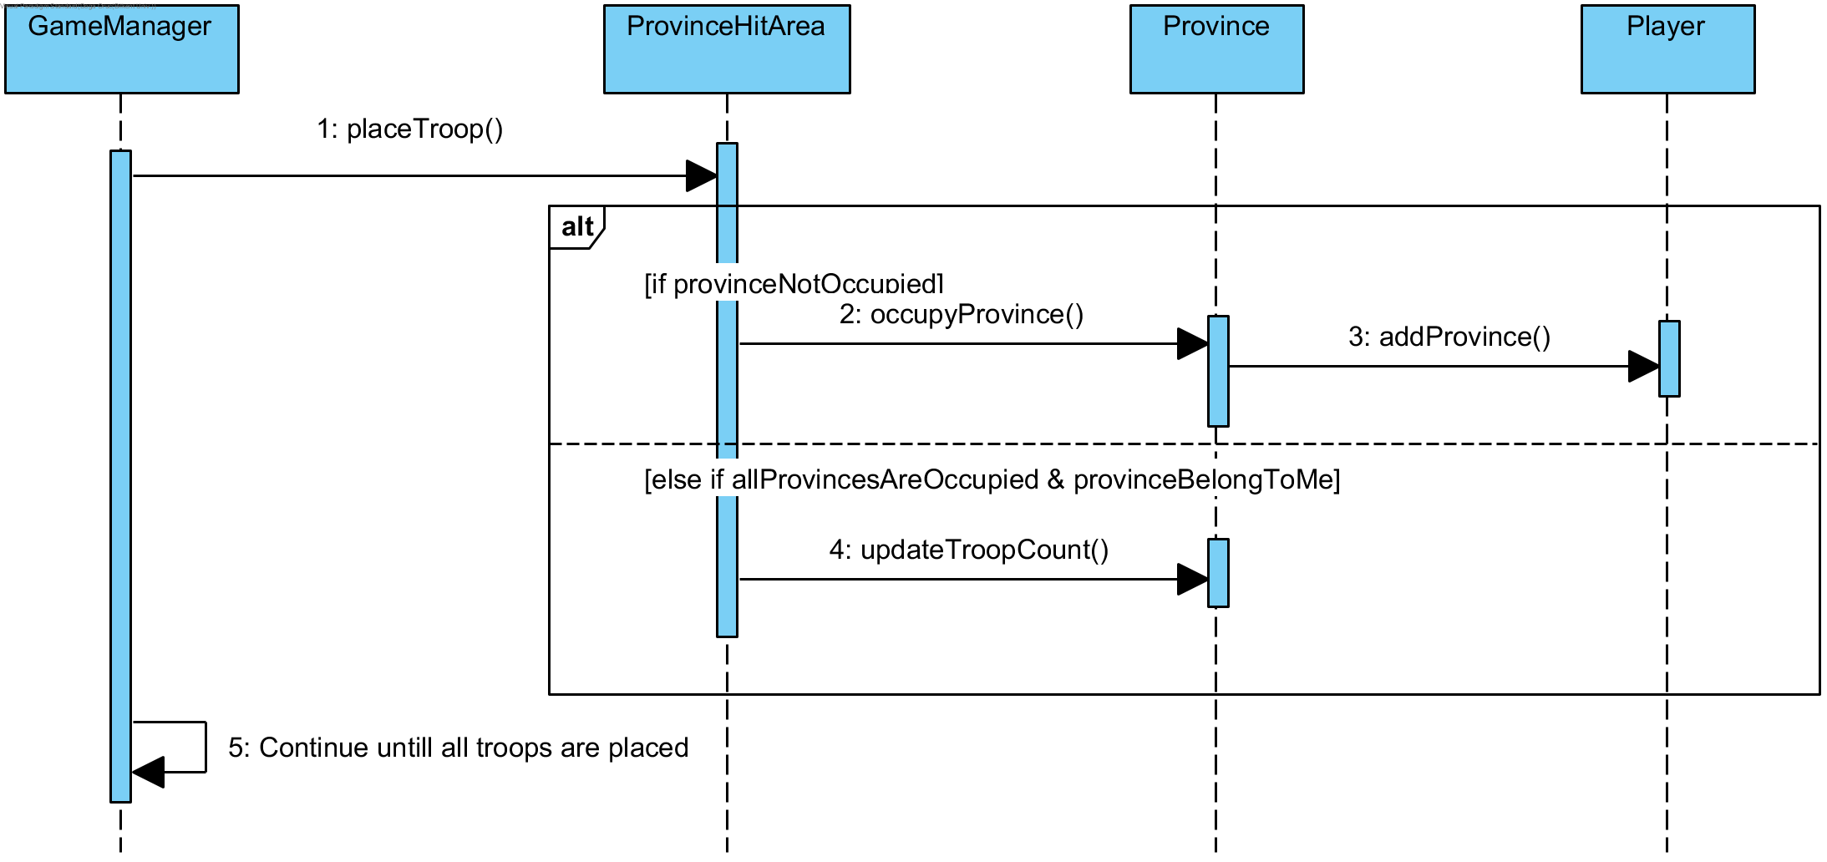

When a game starts, every player must place their starting troops to the game map one by one. On one's turn, if not all the provinces are occupied, the player must click one of the provinces which are not occupied to put 1 troop and occupy the province. Otherwise, they will click one of the provinces they own and increase the troop number of the selected province by one. This operation will continue until every player places their starting troops (one player's starting troop count = 50 - 5 * number of players).

## 5.2 Screen Mock-ups

### 5.2.1 Main Menu

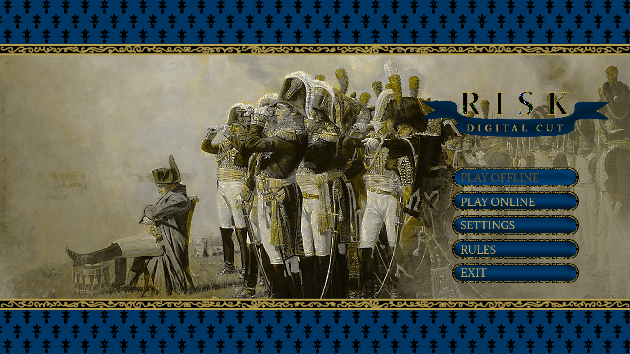

### 5.2.2 Play Online

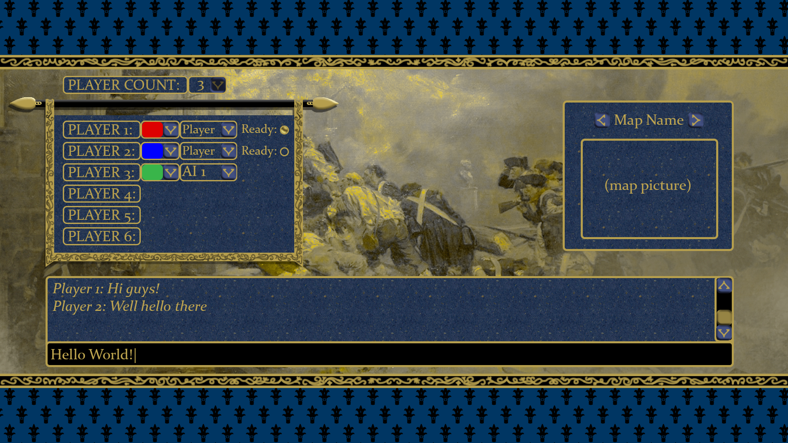

### 5.2.3 Play Offline

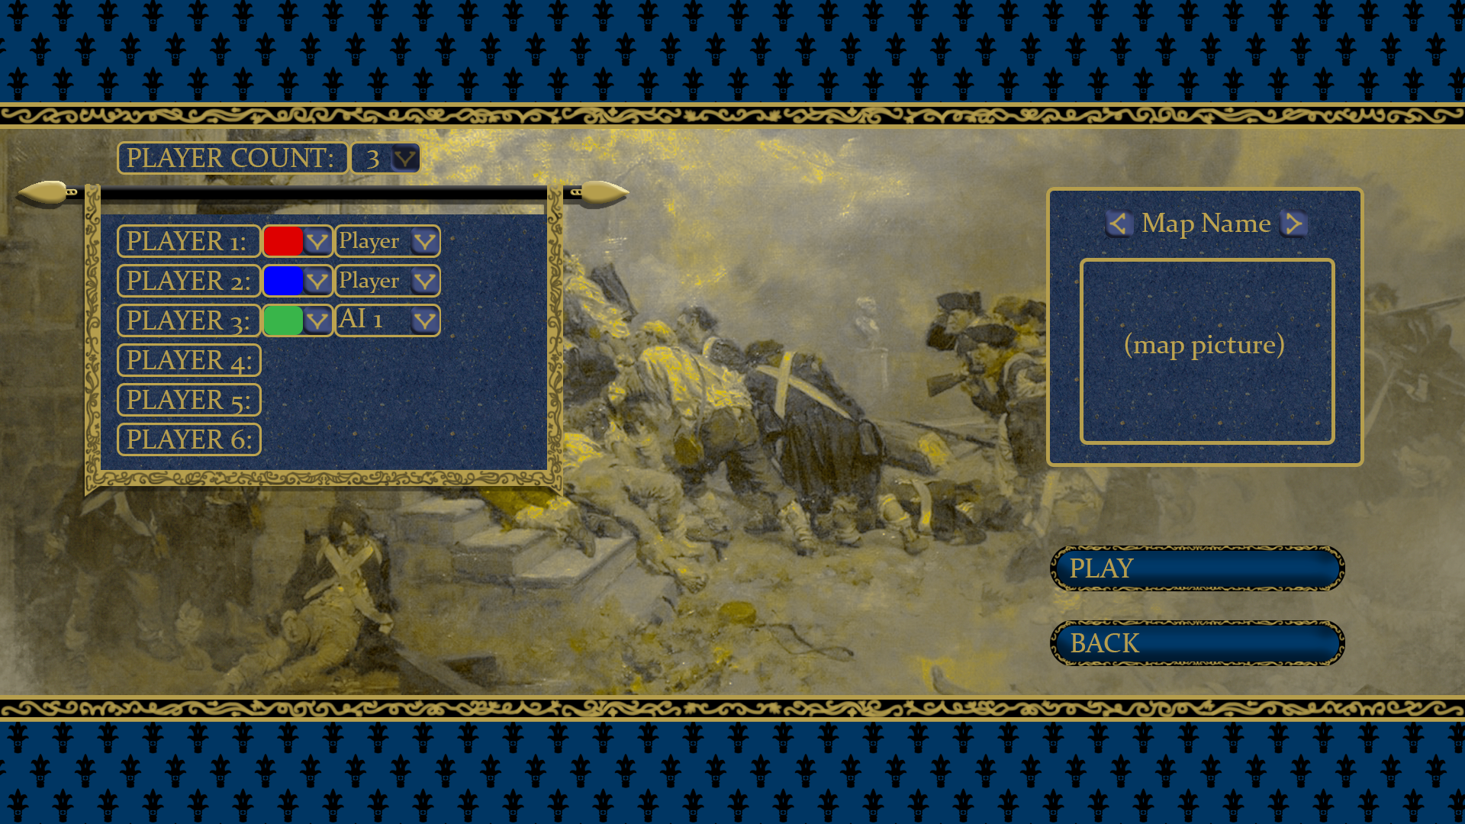

### 5.2.4 Game Screen

#### 5.2.4.1 Old Mock-up

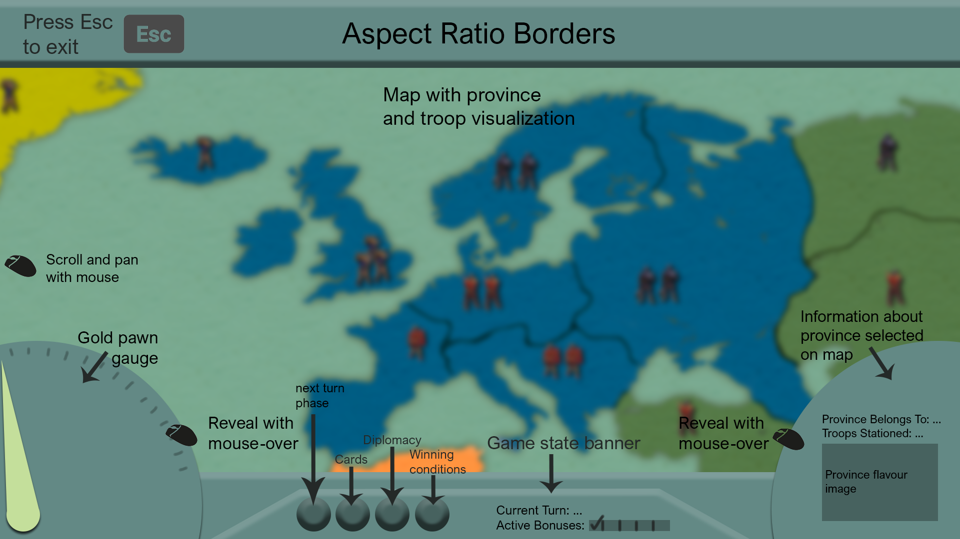

#### 5.2.4.1 Current Visual Version

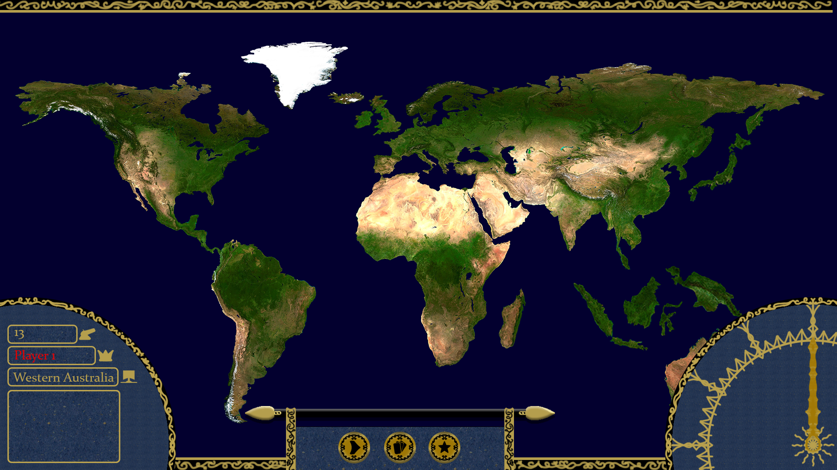

### 5.2.5 Settings

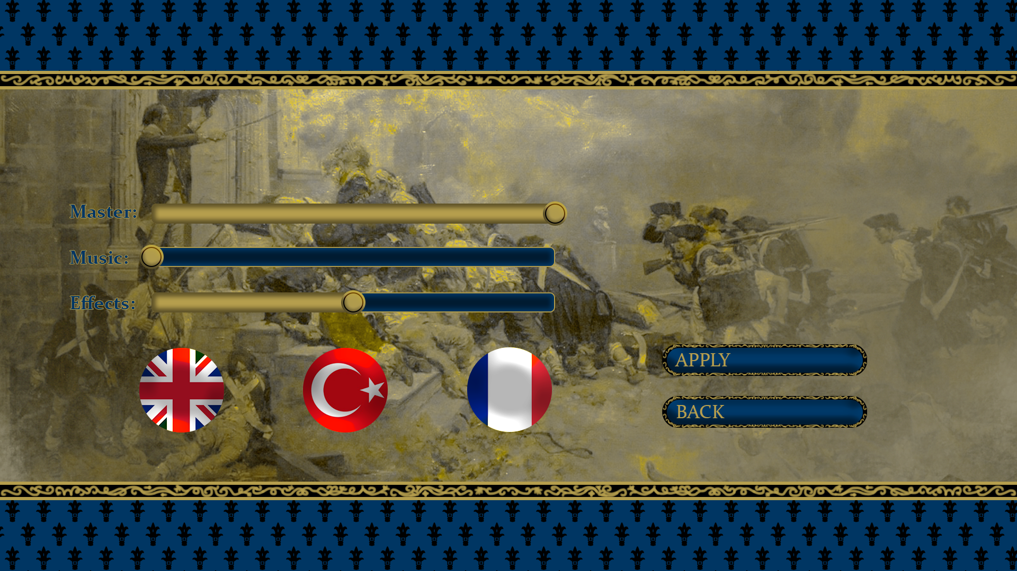

### 5.2.6 Rules

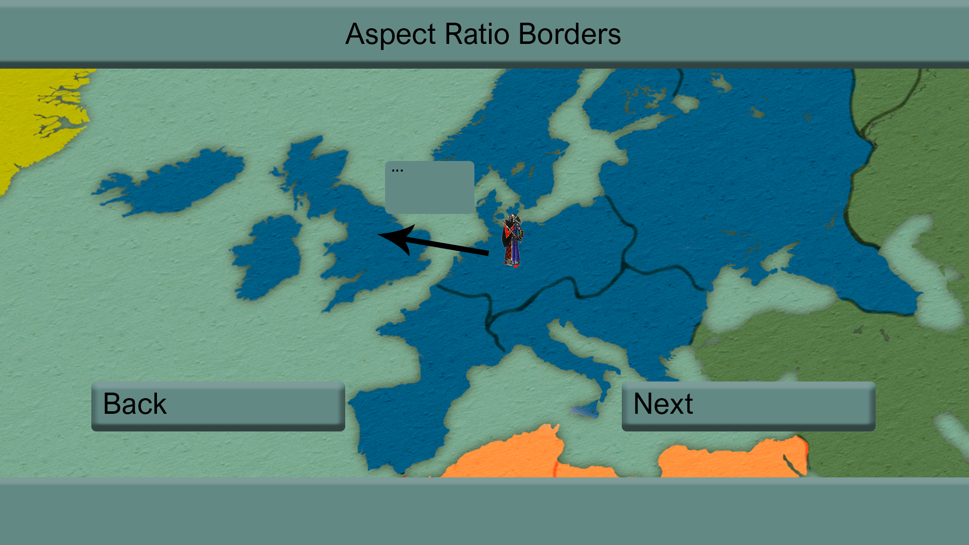

# 6.0 CHANGES AND IMPROVEMENTS

## 6.1 Introduction

We reused the introduction from the first iteration design report as this section serves exactly the same purpose as there. This new version more clearly explains what the Risk game essentially is.

## 6.2 Proposed System

With a clearer vision in mind we have reworked our expectations. As the scope of this part is similar to the same section in the design document, we have taken parts from that report that made sense here.

## 6.3 Functional Requirements

Two new functional requirements have been added:

1. Custom Map Addition Support
2. Game Saving in Play Offline Mode

## 6.4 Non-Functional Requirements

Non-functional requirements have been revised so that they are more easily quantifiable.

# 7.0 REFERENCES

|  |  |
| --- | --- |
| [1] | D. Gordon, “TotalDiplomacy,” 4 October 2013. [Online]. Available: https://www.cardboardrepublic.com/classics/risk-vs-diplomacy. |
| [2] | UltraBoardGames, “Risk Game Rules,” [Online]. Available: https://www.ultraboardgames.com/risk/game-rules.php. [Accessed 10 March 2019]. |
| [3] | N. Bevan, “Measuring usability as quality of use,” *Software Quality Journal,* vol. 4, no. 2, pp. 115-130, 1995. |